From:

Uranium and Nuclear Waste

If you deck the halls with uranium, wear gloves.

Carly Anderson
Follow
Dec 10 · 9 min read

Key Take-Aways:
- The main source of high-level radioactive waste from nuclear plants is used or “spent” nuclear fuel — bundles of solid metal rods. The US has other high-level nuclear waste as well related to legacy weapons production efforts… waste is less contained, less defined and harder to treat, but it is not related to electricity production.
- Most of the high-level waste produced by nuclear plants around the world (including the US) is stored on-site in spent fuel pools. These deep pools of water shield workers from radiation while removing the heat generated from residual reactions.
- Some high level waste is moved into “dry casks” — metal and concrete cylinders which are stored above ground at 80 sites across the US. These interim storage facilities are licensed for 20–40 years.
- The amount of waste produced by nuclear power plants is surprisingly small — the waste from a reactor supplying a person’s electricity needs for a year would be about the size of a brick, and only 3% of that would be highly radioactive.
- While many countries have stated that they plan to create geologic repositories for nuclear waste, none are yet operational. Facilities in Finland, Sweden and France are being actively constructed. [So was Yucca.]
- In my view, nuclear fission as an important bridge [to what??] to power us through the next 30–50 years… and perhaps life on the moon and Mars one day.
- [This person needs her nose rubbed in articles on information about Legacy Waste. –FNC]


When many people think of nuclear power, radioactive waste comes to mind. Where does this radioactivity come from? What types of waste do nuclear plants generate, and what happens to it?

From Rocks to Fuel Rods
The fuel used in most of today’s nuclear reactors is made from naturally occurring uranium oxide (U3O8), which is mined on almost every continent. Kazakhstan (42%), Canada (13%) and Australia (12%) produce the largest share of the world’s uranium, but many other nations also produce significant amounts.
Did you know: The slow decay of natural uranium in the ground produces radon, which is usually too dilute to be harmful but can concentrate in basements. Long-term radon exposure is the second biggest cause of lung cancer, behind cigarettes. Stuck at home for a while? Might be a good time to test for radon.
Naturally occurring uranium is a mixture of two isotopes, uranium-238 (~99.3%) and uranium-235 (~0.7%). Uranium-235 is the one that is important for nuclear fuel and weapons. Most nuclear power plants use fuel that is about 4% U-235,or “standard assay” low enriched uranium.
Enriching uranium (concentrating the uranium-235) is not a simple process. The chunks of rock from the mines have to be separated and purified to get pure uranium oxide (U3O8), or “yellowcake”. The solid U3O8 then has to be converted into a gas, uranium hexafloride (UF6) to separate the two uranium isotopes. The UF6 gas is spun at very high speeds in a specialized gas centrifuge; because the gas molecules with uranium-238 as the “U” are heavier, they migrate outwards towards the sides. The uranium-235 rich gas is collected from the middle. The enriched rich gas is then sent to another centrifuge and the process is repeated many times until the product contains about 4% uranium-235. By looping the gas through the same equipment many more times, it’s possible to enrich the uranium gas to weapons-grade (greater than 90% uranium-235).
This is part of why nuclear power is linked to proliferation concerns — an enrichment facility that can make 4% uranium-235 can make enriched uranium with higher U-235 contents as well. However, because the equipment needed to enrich uranium is complex and expensive, there are relatively few facilities with these capabilities. Urenco USA operates the only enrichment facility in the US, and supplies about a third of the enriched uranium needed to run US nuclear reactors. (Urenco is a British company that operates enrichment facilities in the UK, USA, Netherlands and France.) Other nuclear fuel companies with uranium enrichment facilities are based in Russia (45%), France (12.7%), and China (9.8%), and there are smaller facilities in other countries.

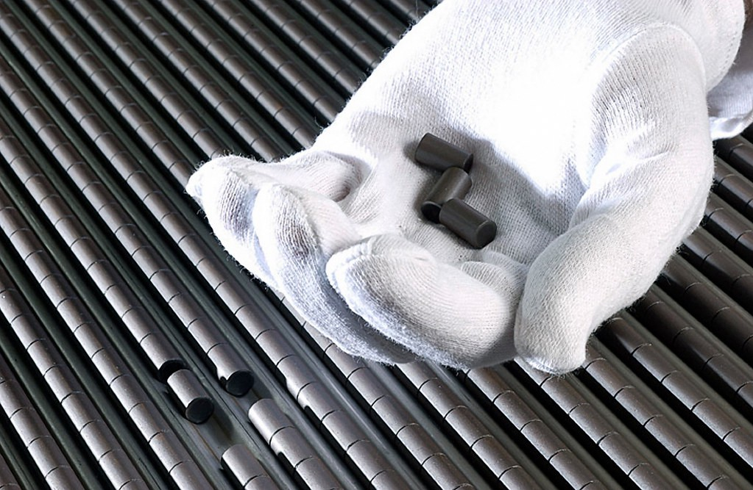
“Nuclear fuel pellets” by NRCgov is licensed under CC BY 2.0
After the enriched uranium goes through more chemical reactions to turn it back into a powder, it’s fabricated into fuel pellets. Fresh nuclear fuel isn’t very radioactive — you can hold it in your (gloved) hand. [1] These pellets are loaded into long metal rods, which are sealed and bundled together into a “fuel assembly”. (For more on how nuclear fuel is made, see this overview from the World Nuclear Association.)
During operation, neutrons strike the U-235 within the fuel rods. If they hit with the right energy, a nuclear fission reaction occurs and U-235 splits into smaller atoms (+ more neutrons, radiation, and energy). These atoms and neutrons continue to fission into smaller atoms through several chain reactions, until they become a stable atom like lead (Pb-207). (For those curious, more physics here.)
At the end of a fuel pellet’s life, it still contains about 1% uranium-235 and 95% uranium-238. The rest are heavy isotopes (plutonium, americium, neptunium and curium) and other fission products. Of these, Cesium-137 and strontium-90 are the most dangerous in terms of their long-term effects. Their half-lives are about 30 years — long enough to stick around, but short enough to pack a radiative punch. Iodine-131 with its 8-day half-life is worse in the short-term, particularly due to its volatility. Because of these, spent nuclear fuel is considered “high-level radioactive waste” and must be shielded (with water, metal or concrete) to prevent radiation exposure.

What Waste Do Nuclear Plants Generate?
Nuclear plants produce three classes of radioactive waste:
- High-level waste (3% by volume), almost entirely used uranium fuel (not glowing green sludge!)
- Intermediate level waste (7%) — typically filters, steel, and reactor components.
- Low-level waste (90%), which consists of lightly contaminated items like tools and work clothing.
Most high-level nuclear waste is the used or “spent” nuclear fuel assemblies. After about 5 years of use, the spent fuel assemblies are removed from the reactor and stored in a spent fuel pool. The water in the spent fuel pool both cools the assemblies and provides shielding, so you can walk around the pool safely. (What would happen if you swam in it?) At this point, the fuel assemblies still produce some heat and radiation, which falls off exponentially with time. The fuel assemblies typically chill in the pool for at least ten years — currently, most of the US’s spent fuel is stored in pools at the power plant.

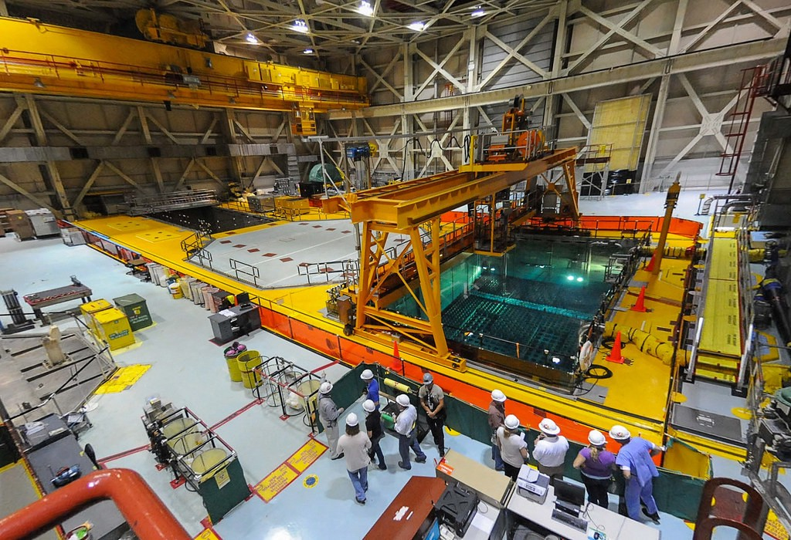
“Spent Fuel Pool of Unit 2 at Brunswick Nuclear Power Plant” by NRCgov is licensed under CC BY 2.0
With Yucca Mountain out of the picture [Will/can there ever be something that good in the future?] , the US’s current storage plans rely on above ground “cask pads” or independent spent fuel storage installations (ISFSIs). These are licensed for 20–40 years, and are usually adjacent to the nuclear power plant (NRC map of ISFSIs). The spent fuel assembles can be placed in dry casks once enough of the decay heat has been removed. These containers typically have a sealed metal cylinder to contain the spent fuel enclosed within a metal or concrete outer shell to provide radiation shielding, and are located all over the US. Dry casking is an expensive process, which encourages utilities to store spent fuel and other high- or intermediate-level waste in the pool if there is space.
Aging Structures Stabilization (Hanford)

Hanford Has a Radioactive Capsule Problem

Researchers still don’t have a way to neutralize the former nuclear-weapons complex’s 1,936 capsules of radioactive cesium and strontium

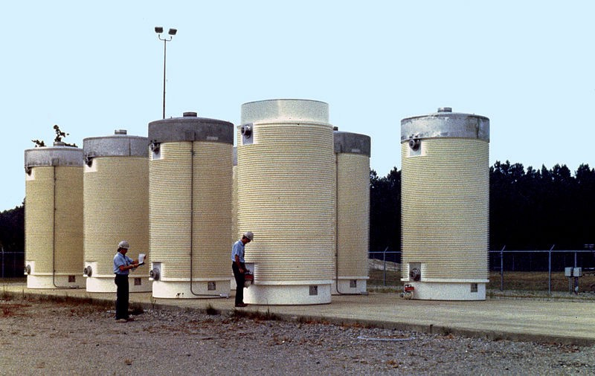
Inspecting a dry cask storage facility (Image Credit: US NRC)

Low-Level Waste
In addition to nuclear reactor operations, low-level waste is produced from medical, academic, other uses of radioactive materials. It is typically stored on site until its radioactivity has decayed and it can be disposed of as trash, or until there is a large enough shipment to a low level waste disposal facility. After processing, it can be permanently disposed of in standard facilities. (Much less exciting.)

How much nuclear waste is generated?
According to the World Nuclear Association, the waste from a reactor supplying a person’s electricity needs for a year would be about the size of a brick. Only a small fraction, about 5 grams of that brick would be high-level waste. Per the Nuclear Energy Institute, the entire amount of nuclear waste ever created in the United States would fill one football field, 10 yards deep. Looking ahead, the U.S. Nuclear Waste Technical Review Board estimates the quantity of spent fuel stored in 2048 will be double the 2012 volume. Substantial, but not orders of magnitude greater than what is managed today.
By comparison, a single coal plant generates as much waste by volume in one hour as nuclear power has during its entire history. Coal plants also release more radiation to the environment — “ounce for ounce, coal ash released from a power plant delivers more radiation than nuclear waste shielded via water or dry cask storage.” (Scientific American)
How do other countries handle nuclear waste? [No better. Decision to dump radioactive water from Fukushima ] All are working through similar challenges. High-level waste disposal is always regulated and coordinated by the national government. Several countries have approved plans for long-term underground storage facilities, including France who plans to open theirs in 2025. Sweden is similarly planning to open a long-term facility in 2023. France, the UK, Russia, and Japan reprocess nuclear fuel, which reduces its volume by about 75%.

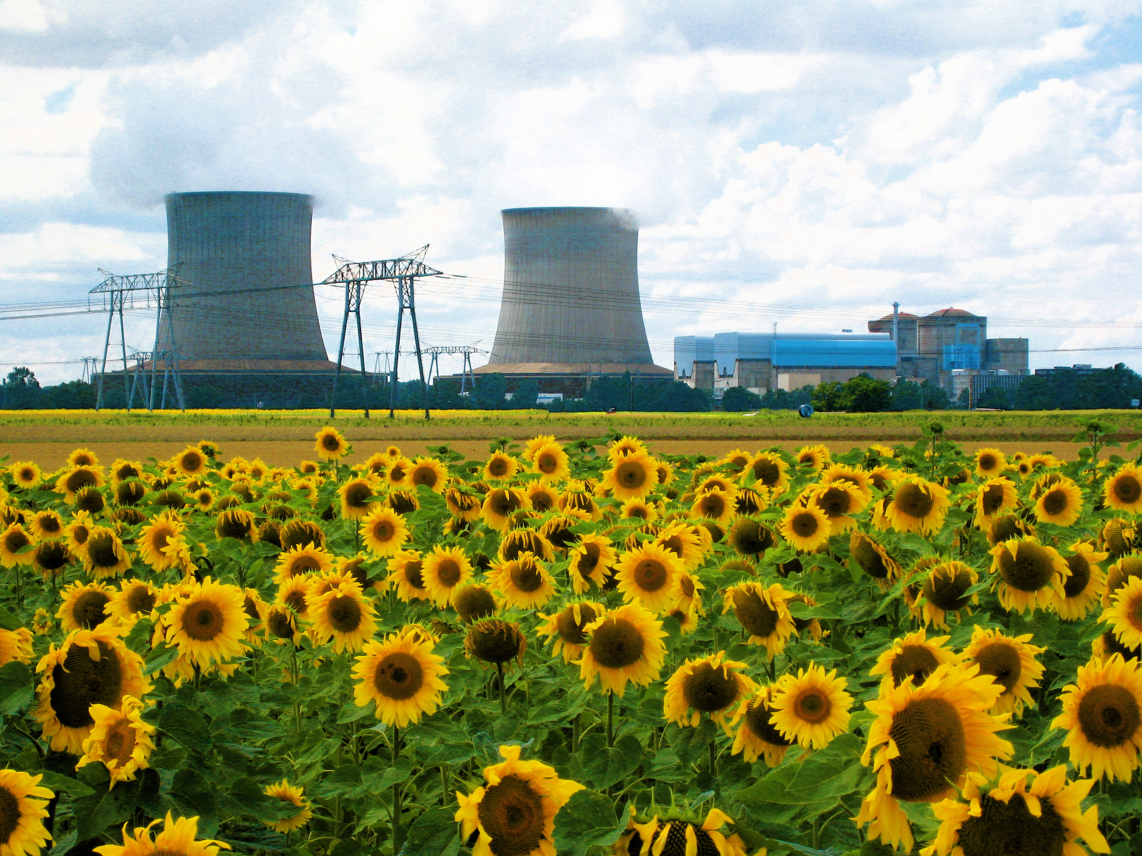
The Saint-Laurent Nuclear Power Plant in France, by Nitot under CC [Notice the cheap propaganda in the foreground.]
There has been significant research (and some work to commercialize) “fast reactor” concepts, that could use high-level waste as fuel and therefore recycle it. Expect more on this and other advanced reactor technologies to come.

A Perspective
I recognize that long-term storage of high level nuclear waste is currently [Since last week? Since last month? Since last year? Since last Century?]an unanswered question. The (albeit small amounts of) fission products we create in nuclear reactors will stick around for centuries, even if we come up with a plan for burying them underground.
I also respect that the nuclear industry reports and helps manage the waste it produces. I appreciate the culture of peer reviews, sharing best practices, and collaborating on technology development both within the US and with the broader international community. This certainly isn’t true of all industries.
In my view, nuclear fission as an important bridge to power us through at least the next 30–50 years, until we can find a way to meet our energy needs with other sources (fast reactors, fusion, renewables and a futuristic electric grid?) Compared to other energy sources, nuclear power is cleaner and produces a fairly small volume of waste[Puhleeze!]. Doubling or even tripling the volume of nuclear waste over the next few decades is relatively minor compared to other environmental challenges we face.
And as I said in my previous post, at the end of the day, my personal view doesn’t matter. We don’t get to decide whether someone half-way around the world builds a new nuclear plant, recycles used fuel, or buries it underground. We can decide to participate in developing safe, efficient, and responsible nuclear technologies, and to have a seat at the table.

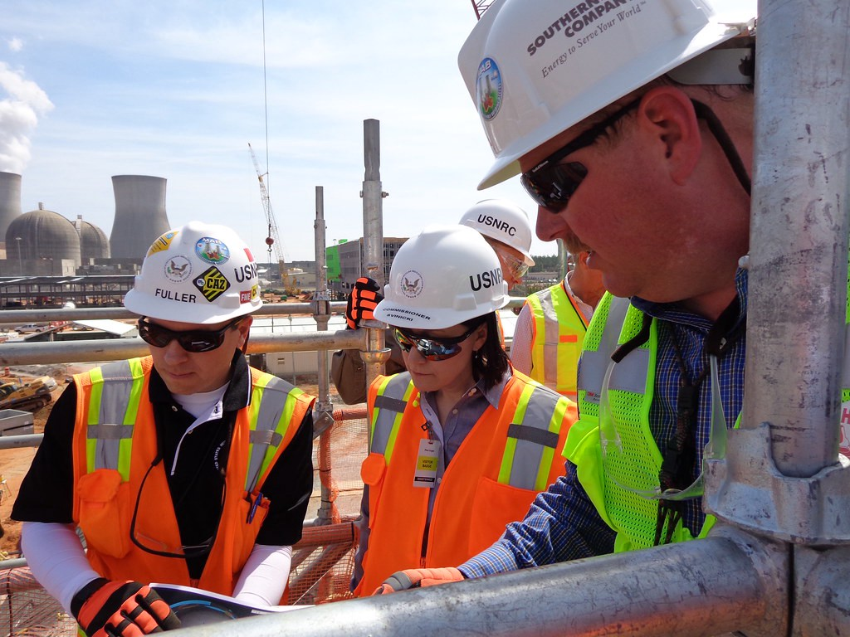
“NRC Commissioner visits Vogtle, GA Construction SIte” by NRCgov

Notes
- Uranium-235 and -238 aren’t significantly radioactive (when they aren’t getting hit by neutrons) — their half-lives are hundreds of millions of years. However, as a heavy metal [And] uranium is chemically toxic.
I gratefully acknowledge the input of smart engineers and nuclear industry members who informed this post, as well as the Nuclear Regulatory Committee (NRC) for making wonderful images available through creative commons licensing!

And this has been true since before you were born!

